SALARY SLIP  Billed To: | 
  Name | : | Rafif Muhammad Rasyad
  ID | : | 141107
  Rekening | : | -
  NIK | : | -
  Address | : | -

No | Date | Program | School | Fee | Foto GPS
1 | 27/07/2026 | Robotic Besar (Smtr 1 - Pert. 1) | SAIM Elementary Kota Surabaya | - | 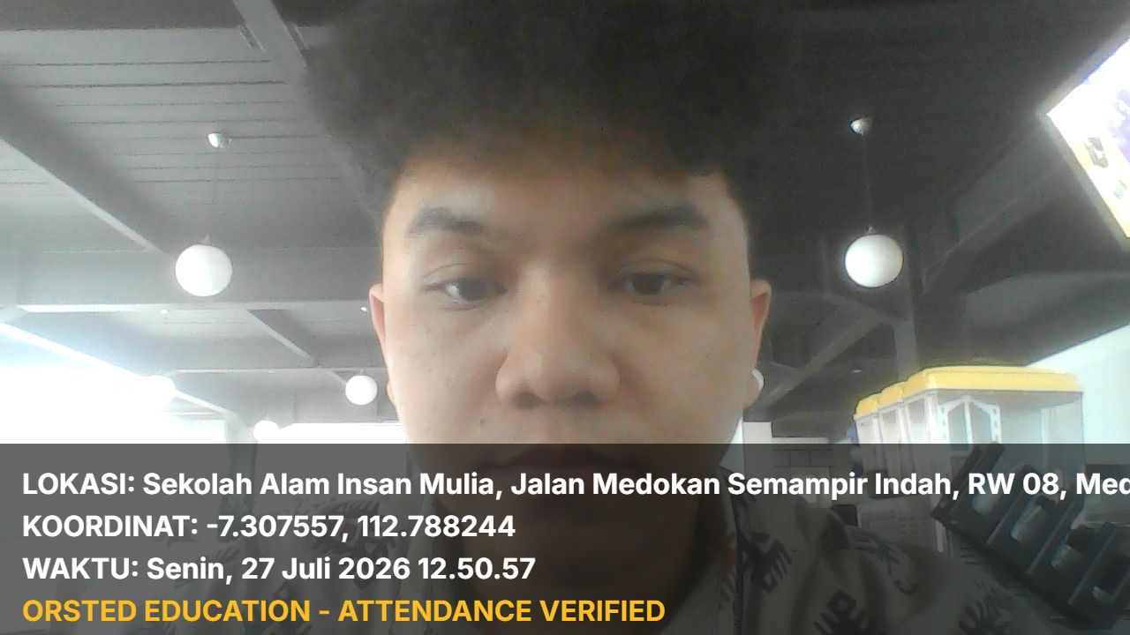
2 | 27/07/2026 | Programming (Smtr 1 - Pert. 2) | MA Alif Laam Miim Kota Surabaya | - | 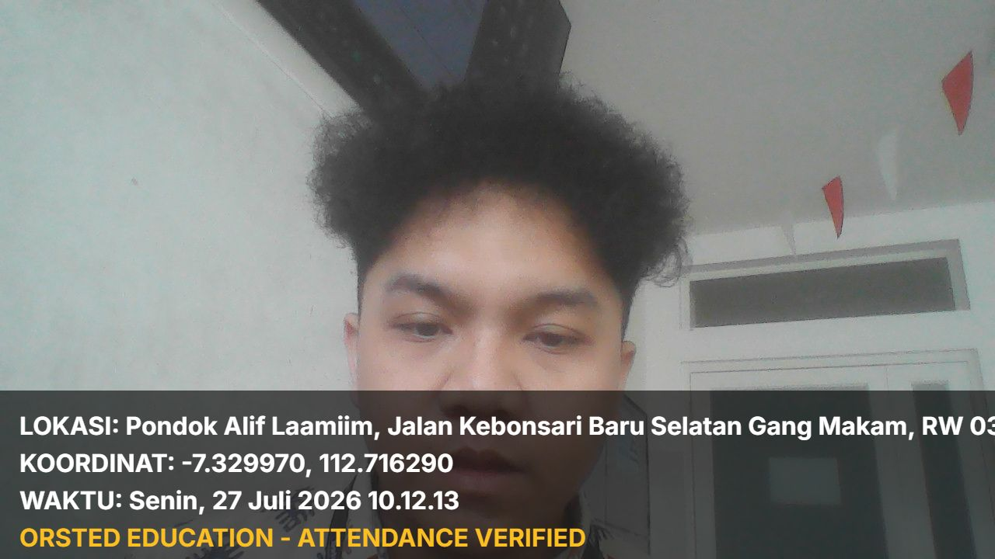
3 | 25/07/2026 | Robotic (Smtr 1 - Pert. 1) | SD Raden Paku Kota Surabaya | - | 
4 | 22/07/2026 | (Smtr 1 - Pert. 1) | SMA Muhammadiyah 10 Kota Surabaya | - | 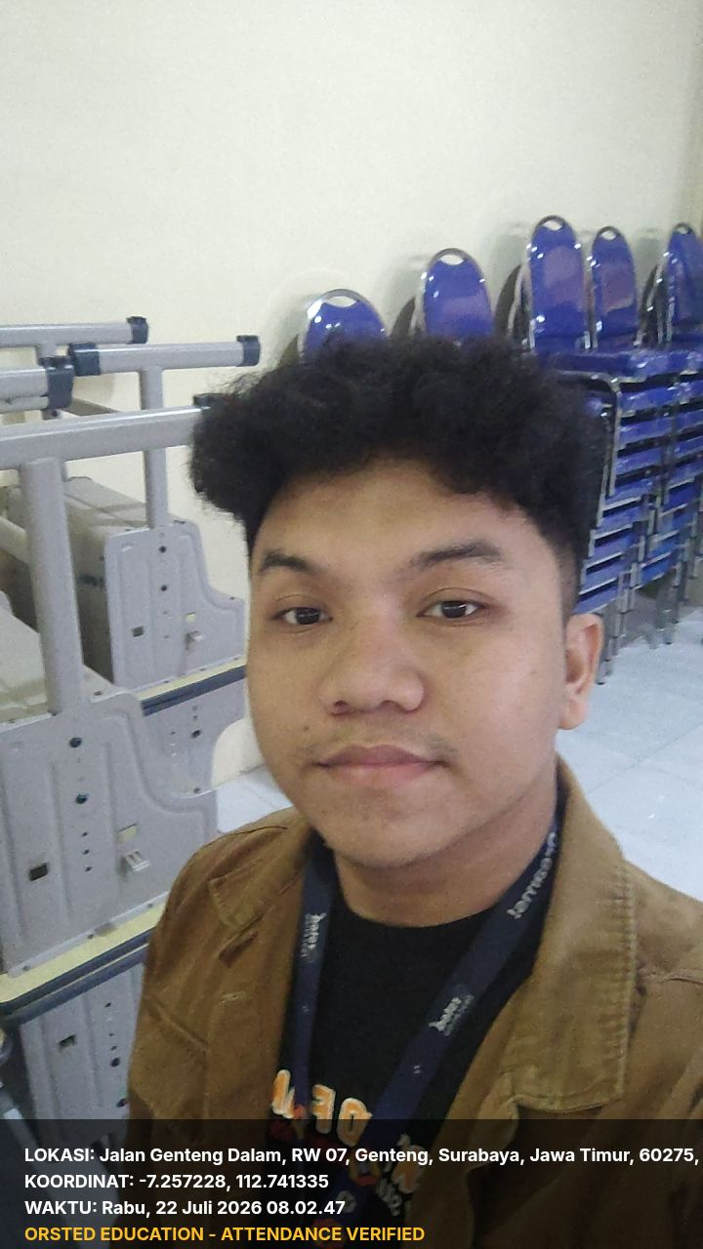
5 | 21/07/2026 | (Smtr 1 - Pert. 1) | SMA Muhammadiyah 10 Kota Surabaya | - | 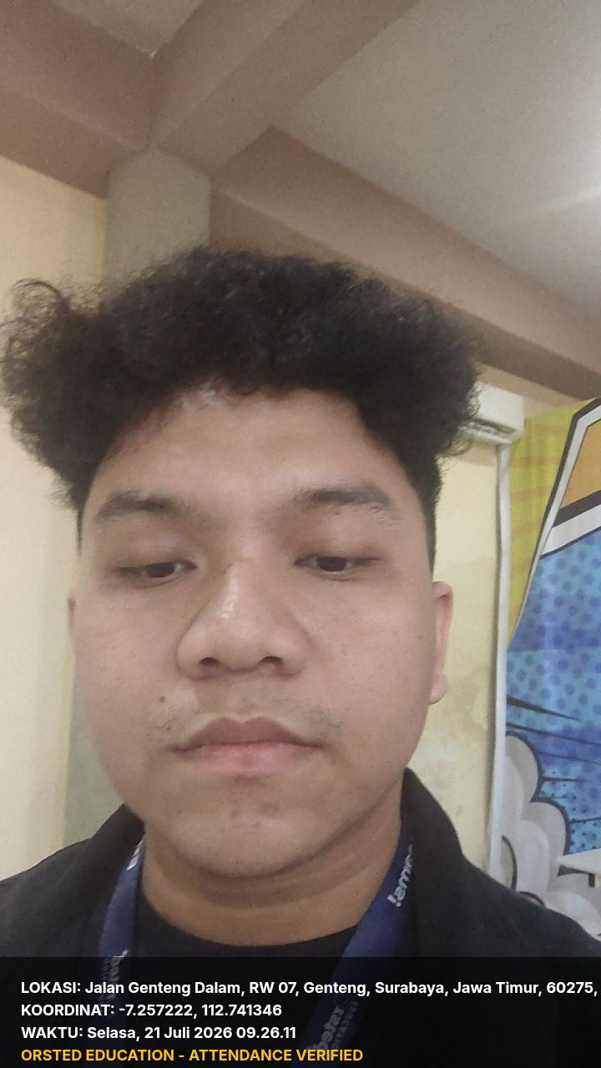
6 | 18/07/2026 | Spontan Joblist - Kelas Tambahan (Smtr 2 - Pert. 3) | Spontan Joblist | Rp 0,00 | 
7 | 18/07/2026 | (Smtr 2 - Pert. 1) | MTs Alif Laam Miim Kota Surabaya | Rp 0,00 | 
8 | 16/07/2026 | Spontan Joblist - Kelas Tambahan (Smtr 1 - Pert. 1) | SAIM Elementary Kota Surabaya | Rp 50.000,00 | 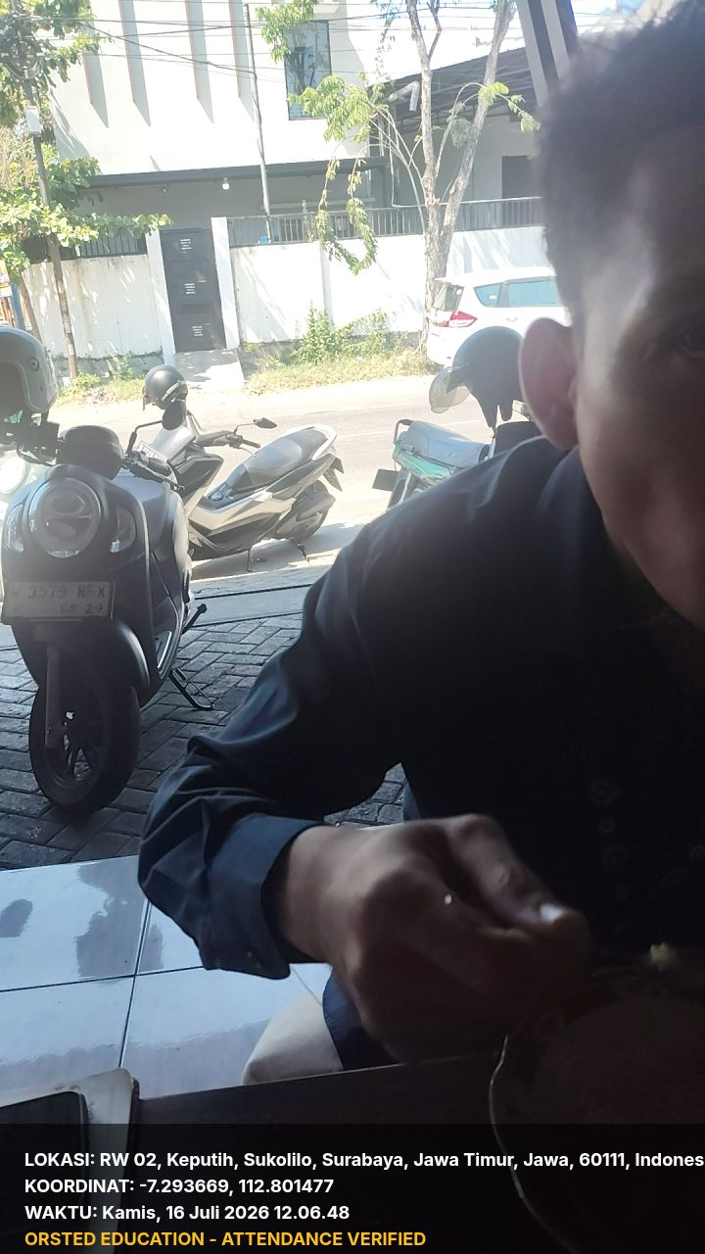
9 | 16/07/2026 | Spontan Joblist - Kelas Tambahan (Smtr 2 - Pert. 1) | SAIM Elementary Kota Surabaya | Rp 50.000,00 | 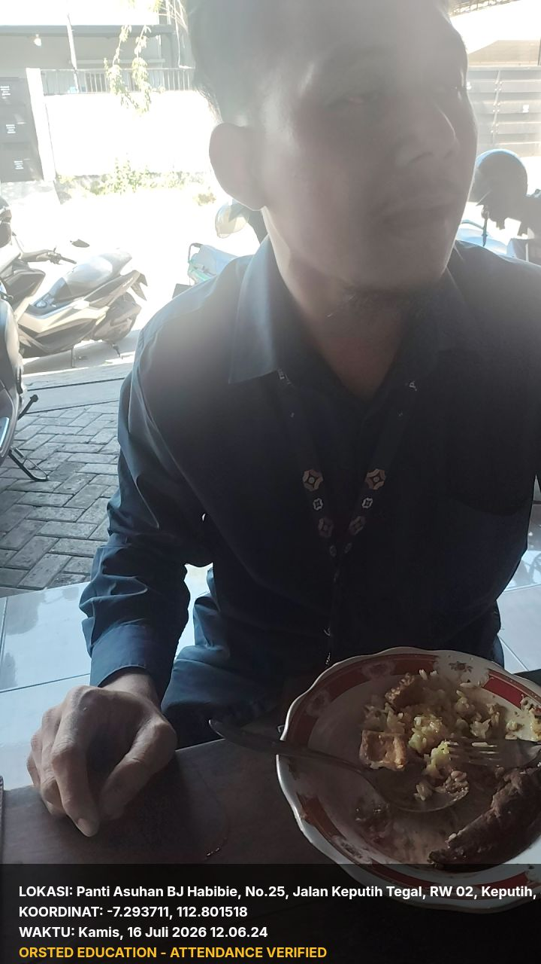
10 | 16/07/2026 | Spontan Joblist - Kelas Tambahan (Smtr 2 - Pert. 1) | SAIM Elementary Kota Surabaya | Rp 50.000,00 | 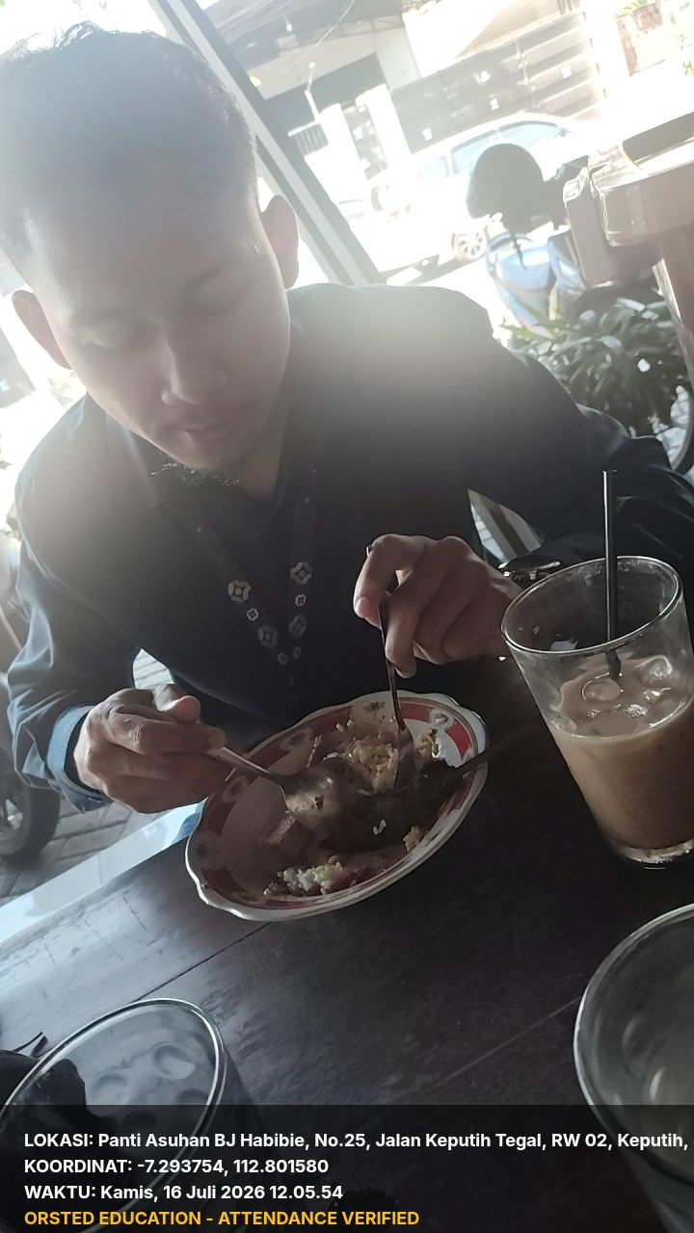
11 | 01/07/2026 | Spontan Joblist - Kelas Tambahan (Smtr 2 - Pert. 20) | Spontan Joblist | Rp 150.000,00 | 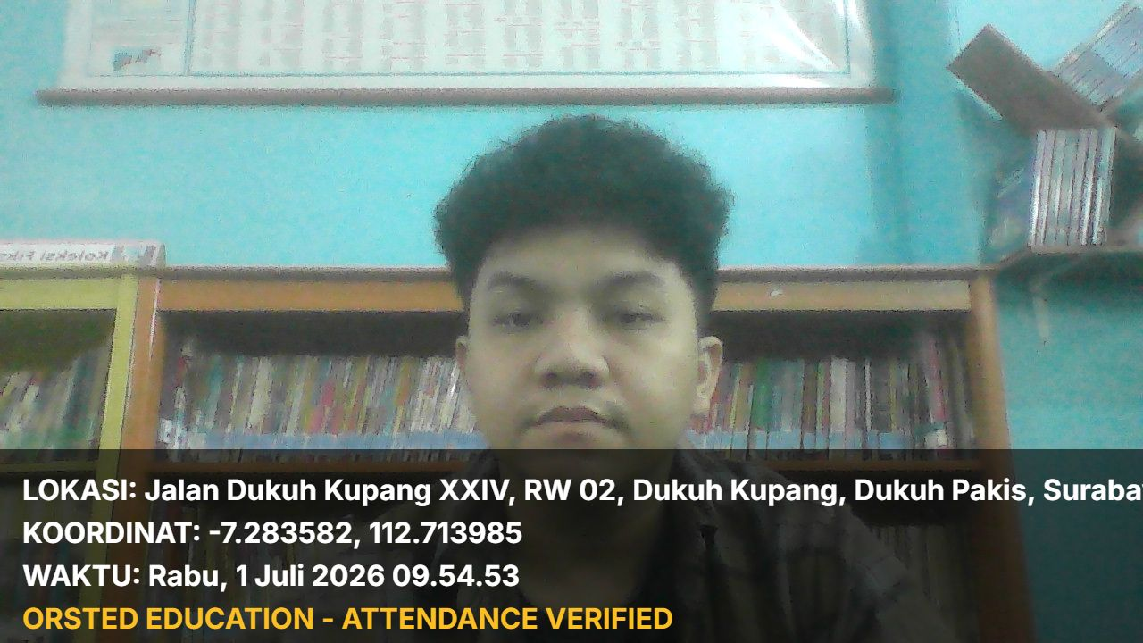
12 | 01/07/2026 | Spontan Joblist - Kelas Tambahan (Smtr 2 - Pert. 2) | Spontan Joblist | - | 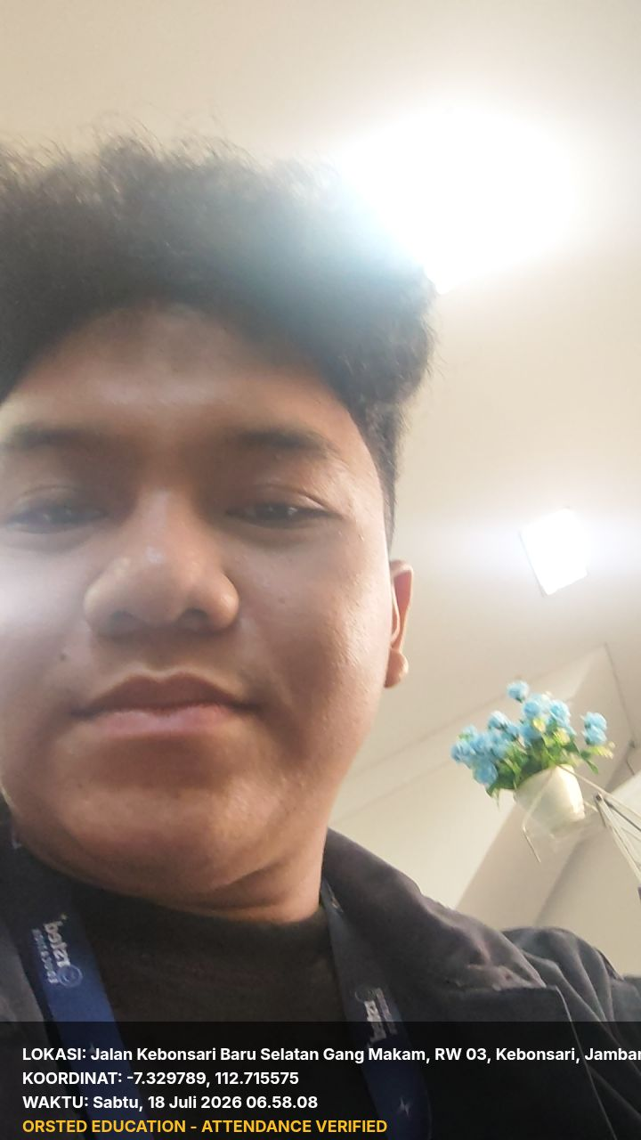

Subtotal | : | Rp 300.000,00
Bonus | : | Rp 0,00
Insentif | : | Rp 0,00
Potongan | : | Rp 0,00
Admin Bank | : | Rp 2.500,00
Total | : | Rp 297.500,00

Dicetak oleh Orsted Sistem: 28/07/2026 01:12

